Archeology
Name:
Professor:
Course title:
Institution:
Date:
Site gridding and documentation involve the most important parts of archeology. Not only does it help to gather information about the past activities but also important aspects of the life led by the population that inhabited that particular site (Hodder,2011). This brought about the do a similar check in the backyard to obtain and get habituated to the practice as well as the challenges of archeology in this piece of work.
The potential site for this report is a large field that borders a permanent stone building on its northern direction. On the southern end is a stream. The site depicts fresh human activities. The likely activities are walking and playing as is evident from the exposed earth's surface. The works of nature are clear too. There are sheets and splash erosion, highly exposed on the surface with small reels and depressions that seem resultant from continued action. The site is 60 meters by 40 meters area whose elevation is roughly 15o tapering towards the stream. There is a footpath across the field sometimes used by cyclists and motorists.
Detailed investigation of the site indicates the softness of the ground. This implies that it can easily be dug using a hoe or shovel, However, some areas in the playground are hard. There are also fringes. These fringes are covered by grass that looks carpeted especially on the entire stretch of the stream. A keen look on the soil, one can notice iron pieces, small pieces of stone flakes, stones, potsherds, wood fragments, and small rocks. Some of the materials in the site look old, some tattered like some pieces of fabric, and others appear rusted. Moreover, others are broken and need to be fitted together for accurate mapping to discover their real identity. There are soiled pieces of plastic, tins, and bags that are slightly visible from the ground.
On the large wall that borders the backyard are many faint paintings. Some of the paintings are human faces that seem antagonized. Others are of circular objects with spikes that are faintly green and next to them are sad faces whose mouths and noses are covered. There are writings but none is readable. The fragmentation of the area into equal parts and segregating the specific areas as per the type of artifacts found is essential in unleashing any clues behind the presence of the materials at the site.
There are many artifacts unearthed from the site. A majority are of great significance. These include metal parts, broken glasses, charcoal pieces, minute bones, old garments, wood fragments, stone flakes, rocks, plastic pieces, and stones. The artifacts are of different shapes, sizes, and different colors through a majority are very faintly colored. Some of the pieces of glass were thick. They look like parts of big bottles and glass vessels. A majority are thin. They are transparent with some having shiny luster. Some are red, green, and orange while others are maroon. Other pieces of glass look like they had been molded into circular shapes. This shows they could have emanated from round vessels or bottles but others are broken bottles. A majority of the glass pieces are near the stream and at the field peripheries.
There was a potsherd that appeared in different sizes and shapes. Some were in small pieces while some were huge. Some were black and most of these appeared to have been parts of larger circular objects. The black substance on rough erasure would come out in dust like form. There were large stones and on most occasions, the large stones near the black potsherd were mostly in threes. Some of the pieces were multi-colored, painted in brown, and had different patterns. It was also around these black ones that lay small pieces of charcoal and some plastic pieces too. The plastic pieces looked like remnants of hollow cylindrical, bowel-like objects. Other potsherds had patterns similar to the drawings on the wall, but the colors on these particular ones were dull-colored. A large piece of the potsherds had a smooth interior with what appeared like soil layers that had formed lines.
Some of the metals had been eaten by rust. However, others had been joint together and appeared like chains. Also, they were conjoined with some pieces of broad wood. Two metal obtained from two opposite and apart segments were curved into the letter 'C' but with angular corners. The smaller pieces of metals, mostly at the fringes were very flat and sharp blade-like objects. Others looked like parts of circular objects. Some had smaller holes within them while others had thin spike-like rods emanating from them.
The wooden fragments had been eaten by termites and it was quite difficult to decipher their forms. However, some had pieces of small, sharp iron pieces stuck on them. They also had loose pieces of fabric remnants attached to the smaller and thinner pieces of iron. Besides, there were small pieces of sponge-like material were found these sort of wooden fragments.
There were small pieces of stones on what looked like a pathway across the field. There were potholes within which were larger pieces of stones. They looked like they had been eroded. Around the field were smaller stones but they looked like black chippings and a few had white coloring.
The minute bones were distributed in almost every segment. The old garments were mostly along the stream and at the fringes of the field. However, within the field was a circular lump of clothes that had threads wound around it. There were similar, plastic-like circular objects too.
Judging from the artifacts, the place must have been a bee-hive of activities. Probably the population used glass for decoration and also for their home use like storing liquids. Although this is based on the fringes a larger reflection comes in observing those near the stream which perhaps had been deposited there by water from neighboring areas. Evaluating the potsherd, the population used them for cooking purposes and maybe charcoal as the fuel. Perhaps the stones in threes were used to support the bottoms of the cooking vessels. The multi-colored ones must have been used for decoration especially with the patterns and the soil lines on the interior surfaces indicate that maybe some plants had been planted in them. However, the dull ones whose patterns resembled the drawings on the wall seem to pass a message, a sorrowful one. Probably an enemy that attacked the mouths and noses of the people and one that was in the form of a circle with spikes or maybe one that could spread. The chain-like metals with broad woods fixed on them could have been play-swings. It is, however, difficult to decipher the use of the c-shaped metals but they have a close similarity to modern-day football goal-posts. The circular objects with holes could have been the rims of tires. The evidence of garment fixed with iron pieces could indicate furniture.
The site could likely have been a social place where many different activities took place. Perhaps celebrations evidenced by the cooking and the small bones. Perhaps some sports events took place due to the presence of broken rims and tires and the chippings around the field. It could also be possible that the place was a social gathering area where people would gather to and share their fears and joys as well as address communal problems.
Some of the archeological tools that are necessary for this study include shovels, brushes, paper, and plastic bags, mason's trowel and small pickaxe, graph and lined notebooks, trug buckets, soft bristle brushes, cameras and a microscope(Gaffney,2008). The methods that could be applicable include stratigraphy, dendrochronology, and radiocarbon dating to identify this to possible historical events then. (Kintigh, 2006)There are several challenges in the work, such as data gaps, expenses incurred in conducting an excavation, erasure of relevant details on artifacts, and similarity of events which reduces accuracy.

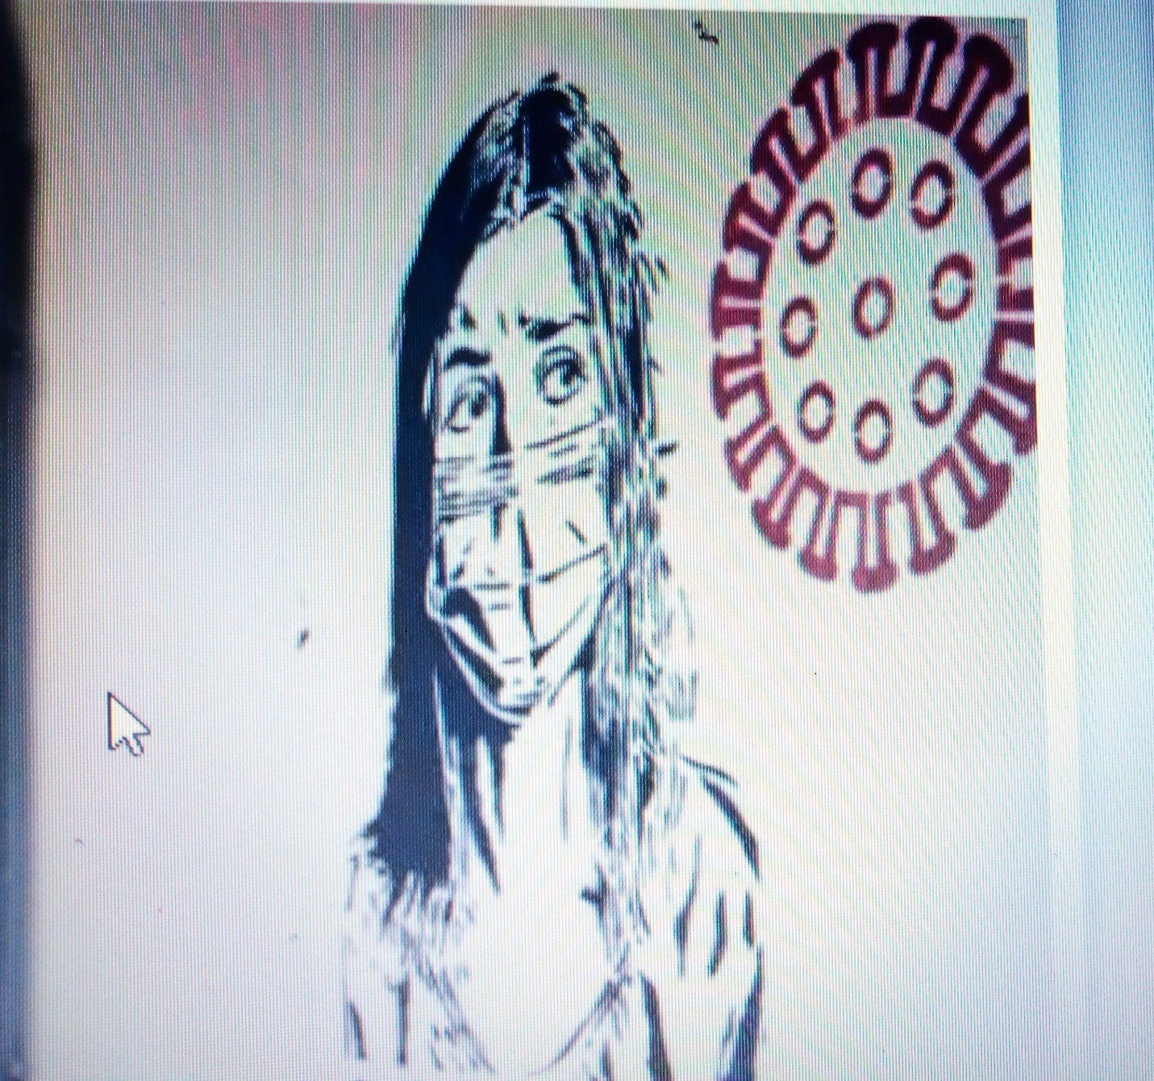

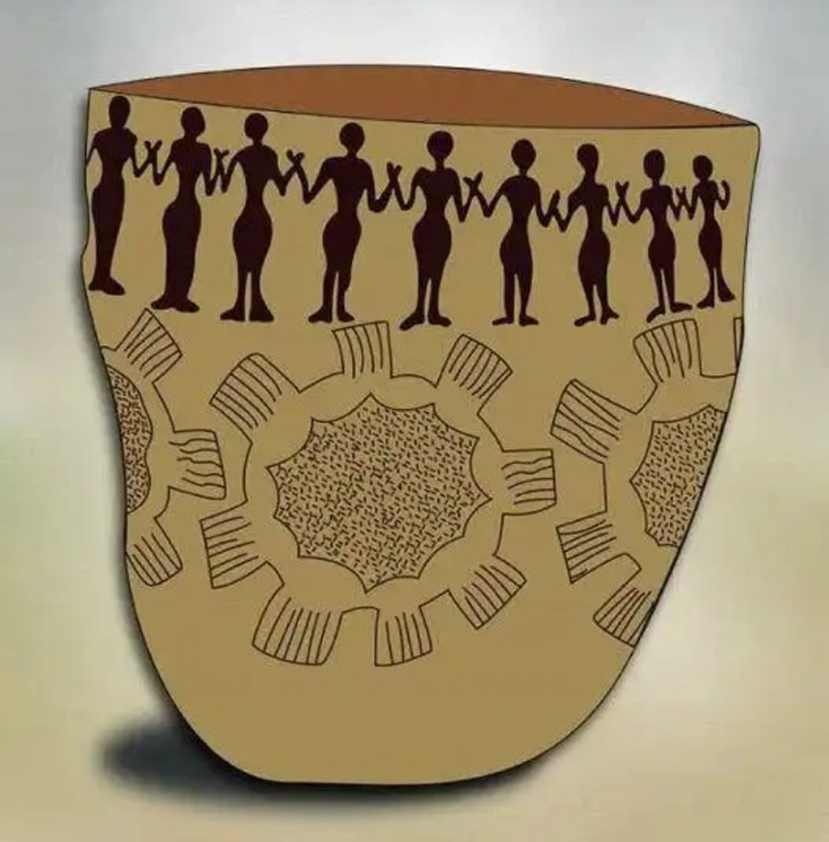


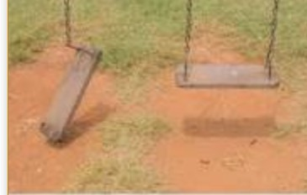
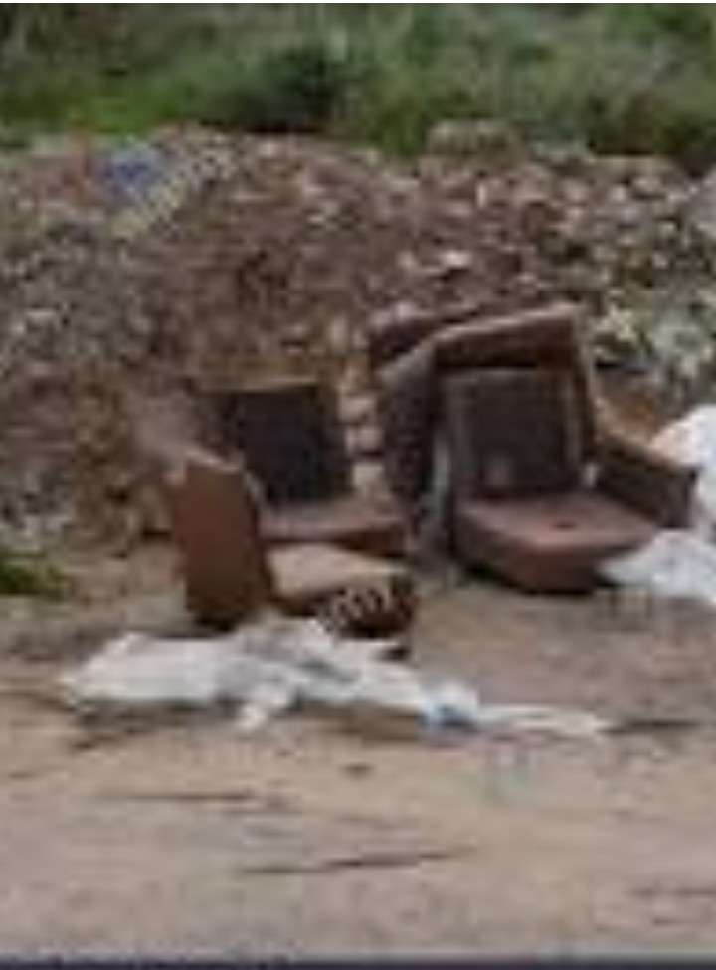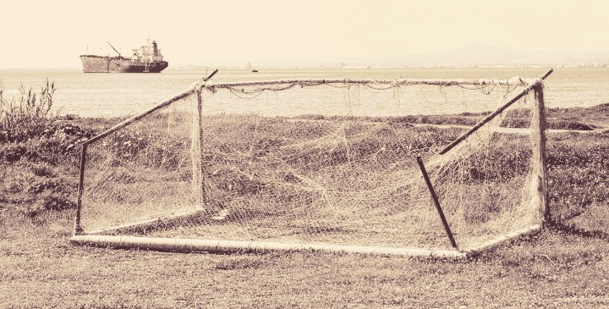
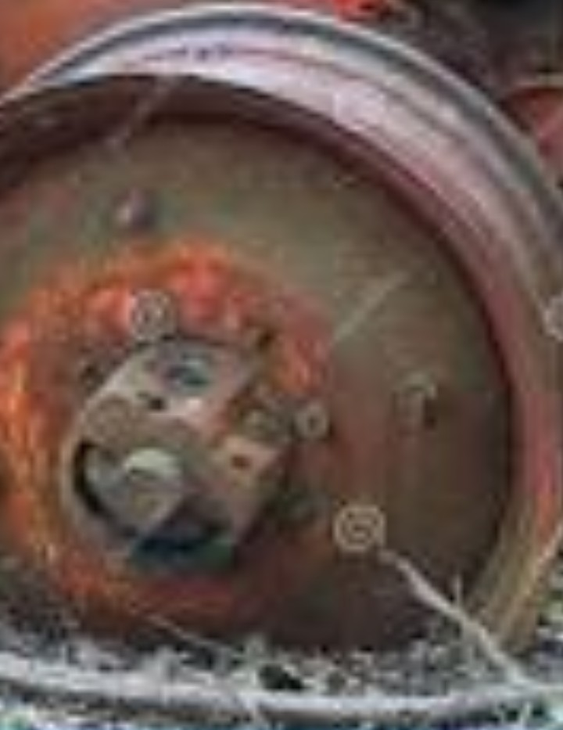

References
Kintigh, K. (2006). The promise and challenge of archaeological data integration. American Antiquity, 71(3), 567-578.
Gaffney, C. (2008). Detecting trends in the prediction of the buried past: a review of geophysical techniques in archaeology. Archaeometry, 50(2), 313-336.
Hodder, I. (2011). Human‐thing entanglement: towards an integrated archaeological perspective. Journal of the Royal Anthropological Institute, 17(1), 154-177.

